Electron Workflow

Unlike website, **ELECTRON** is run on two separate environments/worlds

* **Main World** for UI Web Content
* **Isolated World** for Main Process (Node.js Backend)

**IPC is acting as a walkie-talkie between preload.js and backend API function**

Important Steps to make your electron app less risky.

| function createWindow() {  webPreferences : {  nodeIntegration : false,  *//preventing* *node.js* *access* *to* *users*  contextIsolation : true, *//preventing* *window/dom* *manipulation* *by* *users*  } } |
| --- |

contextIsolation is set to default **true** by Electron

* Have to communicate through contextBridge inside preload.js
* Use IPC (Interprocess communication) to request backend nodeAPI to do the task
* Preload.js acting as a layer allowing specific task/function to call & one backend API func per message
* To prevent hackers access to global javascript window function to overwrite.

If contextIsolation : **false**, then it shares the same window object meaning users can access the whole object without using Bridge. As a result, hackers can access to modify a **Global Variable**, resulting as below.

| Before Modification:  window.userData = { name: "John Doe", isAdmin: false }; console.log(window.userData.isAdmin); *// ✅ false*  Hacker Injects Code: window.userData.isAdmin = true; *// ⚠️ Modifying global variable*  After Modification:  console.log(window.userData.isAdmin) *// ❌ Now prints `true`!* |
| --- |

For example, let’s say UI wants to schedule the zoom meeting, it talks to the preload.js directly **without using IPC**. Then, **preload.js** uses **IPC (Inter Process Communication)** to talk to the backend Node to do the zoom schedule meeting task. If successful, it can send back a “Success” message using IPC.

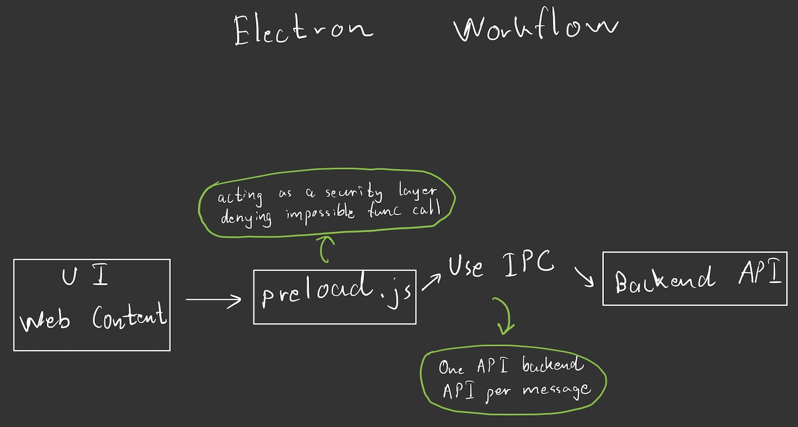

**zoomAutomation.js | Call From UI |**

const **scheduleZoomMeetings** = (*timeSheet*, *zoomLink*) => {

if (!window.electronAPI) {

console.error("🚨 window.electronAPI is undefined!");

return;

}

window.electronAPI.scheduleZoom(*timeSheet*, *zoomLink*);

};

export { scheduleZoomMeetings };

**Preload.js**

const { contextBridge, ipcRenderer } = require('electron');

contextBridge.exposeInMainWorld('electronAPI', {

**scheduleZoom**: (*timeSheet*, *zoomLink*) => ipcRenderer.send('schedule-zoom', *timeSheet*, *zoomLink*)

});

**main.js**

ipcMain.on('schedule-zoom', (*event*, *timeSheet*, *zoomLink*) => {

console.log("Scheduling Zoom:", *timeSheet*);

shell.openExternal(*zoomLink*); *// ✅ Safe operation*

});

Author : Aung Nanda Oo